
CONFIDENTIAL CS/NOV 2026/CSC429

UNIVERSITI TEKNOLOGI MARA FINAL EXAMINATION

COURSE
COURSE CODE
EXAMINATION TIME
COMPUTER ORGANIZATION AND ARCHITECTURE

CSC429
NOVEMBER 2026
3 HOURS

INSTRUCTIONS TO CANDIDATES

- This question paper consists of two (2) parts: PART A (10 Questions) PART B (1 Question)

- Answer ALL questions in the Answer Booklet. Start each answer on a new page.

- Do not bring any material into the examination room unless permission is given by the invigilator .
- Please check to make sure that this examination pack consists of: i) the Question Paper
  - an Answer Booklet - provided by the Faculty

- Answer ALL questions in English.

DO NOT TURN THIS PAGE UNTIL YOU ARE TOLD TO DO SO

This examination paper consists of 4 printed pages.

PART A (80 MARKS)
Answer ALL questions in this part.
QUESTION 1 (5 marks)
Draw the complete machine cycle and explicitly describe the function of each phase and the
location of its occurrence.
QUESTION 2 (5 marks)
- Why is the machine in zero computer generation known as a mechanical computer?
- Complete the following table with the appropriate answer.
Mechanical Calculatin Machine Difference Machine
Inventor
Function
QUESTION 3 (5 marks)
What is the decimal value of the sum of the binary numbers 1101 1100 and 0010 0111 if they
are represented in sign and magnitude? Assume that the basic unit is the byte. Show your
workflow.
QUESTION 4 (5 marks)
- Discuss the computer interface that is available during the third and fourth computer
generations.
- ln your opinion, what is the leading cause that changed the computer interface in the third
to the fourth computer generations?
QUESTION 5 (10 marks)
- What is a cache?
- Elaborate on what will happen if there is no cache in the computer system,
- Comparing L1 and L2 cache, discuss which cache would have faster speed with relevant
justification.
- Discuss TWO (2) policies to write data to the cache to ensure consistency between the
cache and the main memory (RAM).
QUESTION 6 (10 marks)
- List the FOUR (4) classifications of parallel processors and provide examples for each.
- Discuss ONE (1) advantage of using cluster computer architecture.
QUESTION 7 (10 marks)
- List FOUR (4) types of access method for storage device with ONE (1) example for each
of them.
- Calculate the total of memory location using 11 address bit.
- Calculate the address bits required for 2MB of RAM.
QUESTION 8 (10 marks)
- Identify what is X.
- Briefly describe the function of X.
- List the sub-structural component of X.
In your opinion, why X is very important to the computer system?

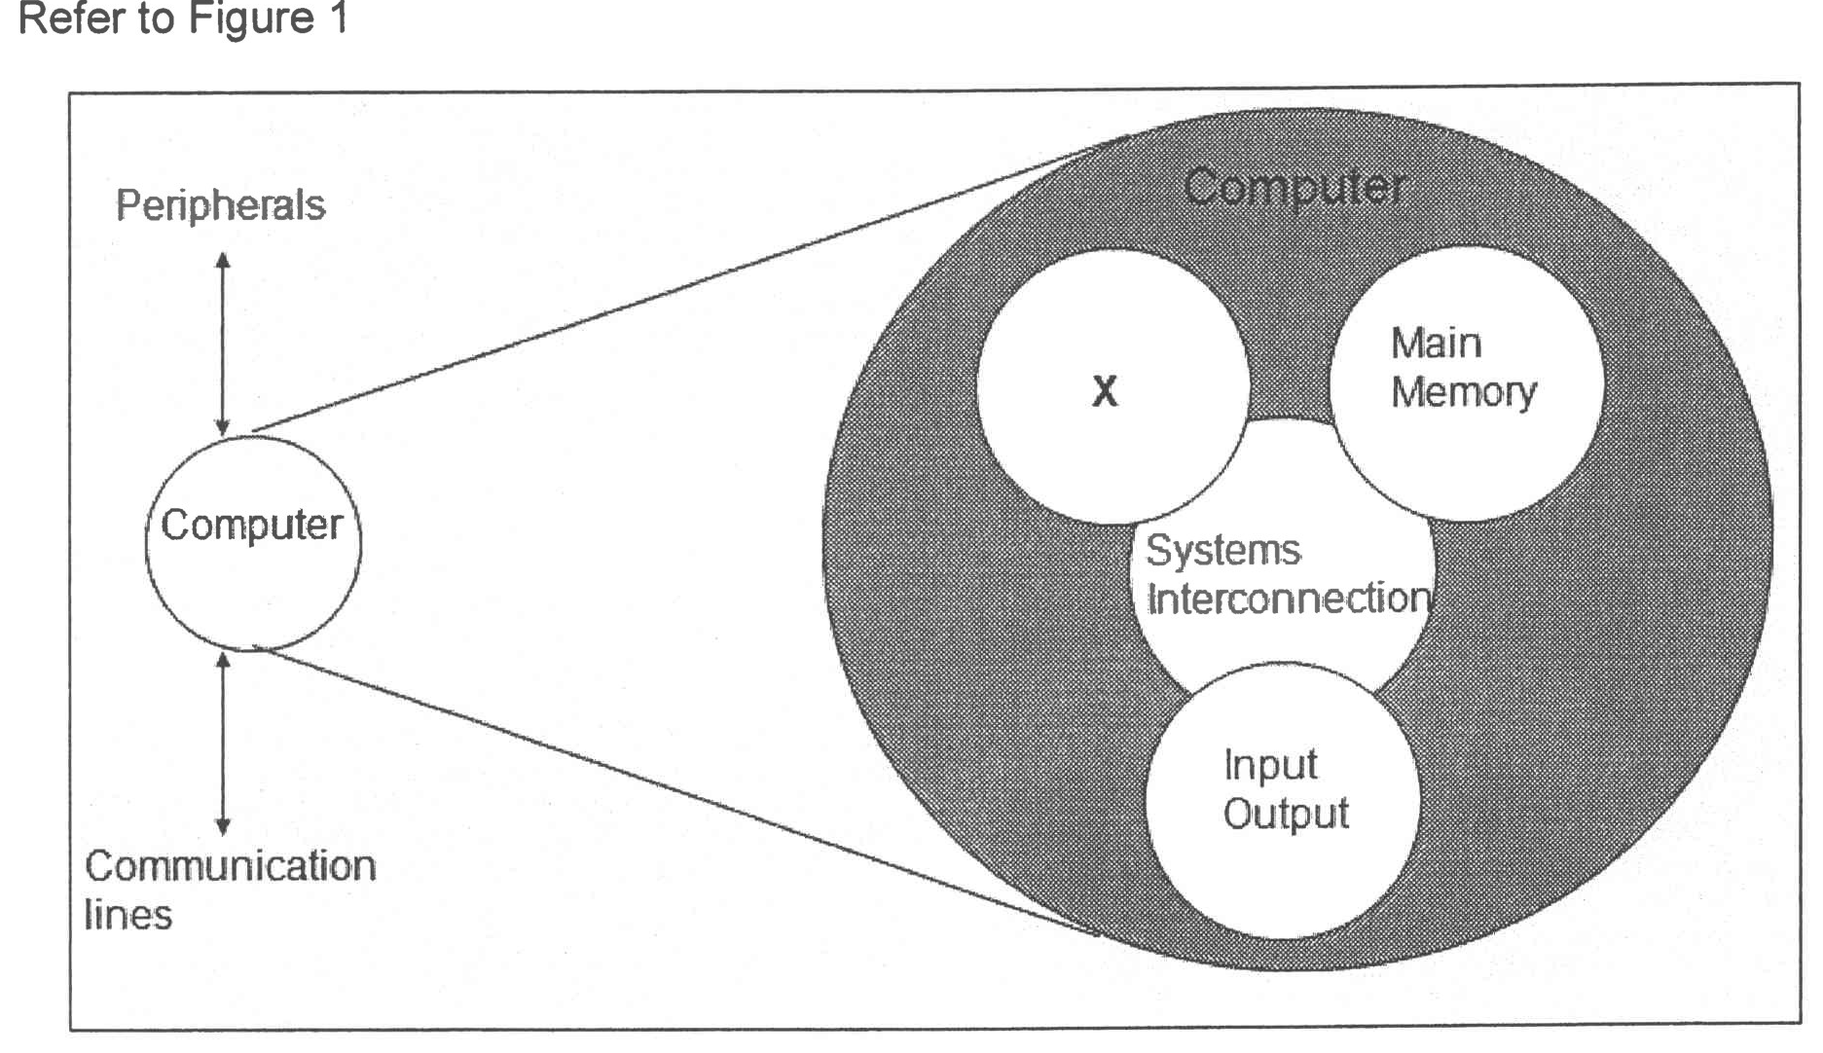
Figure 1
QUESTION 9 (10 marks)
- List TWO (2) buses types that are available in the computer system.
- Differentiate TWO (2) characteristics of system interconnection
and CPU
interconnection.
- Explain the different types of data transfer timing.
QUESTION 10 (10 marks)
- Elaborate THREE (3) types of replacement algorithm.
- List TWO (2) types of mapping that require a replacement algorithm.
- Discuss the reason why the replacement algorithm needs to be implemented.

PART B (20 MARKS)
Answer the question in this part.
QUESTION 11 (20 marks)
Question 1 is based on Figure 2 and Table 1
Write an appropriate program using conect assembly language notations to compute the
equation shown in Figure 2 using instructions for zero-address, one-address, and three-
address. The available instructions are provided in Table 1. The registers labeled A, B, C, and
D are fixed, while registers x, y, and z can be used temporarily. The final answer must be
stored in register z.
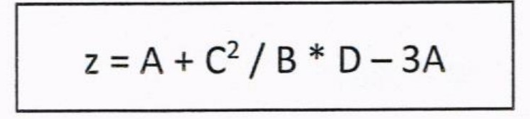
Figure 2
Table 1: lt/achine instruction
Zero-address | One-address | Three-address
PUSH p | LOAD p | ADD (p,q,r)
POP p | STOR p | SUB (p,q,r)
ADD | ADD p | MUL (p,q,r)
SUB | SUB p | DIV (p,q,r)
MUL | MUL p
DIV | DIV p

